pageTitleImage7r



Exor Corporation Limited



Audit Manager

AdminV4.3



# 

The Global Leader in

Infrastructure Asset Management



This page intentionally blank.

Quality Assurance Statement

|  |  |
| --- | --- |
| **Document Details** | |
| **File:**  Audit Manager Admin v4.3.pdf | **Prepared by:**  A Hammond/I Skinner |
| **Manual Name:**  Audit Manager Administration Guide V4.3 | **Reviewed by:**  **I Skinner** |
| **Version:**  3.0 | **Approved for issue by:** |
| **Date of Issue:**  Nov 2010 | **Product Manager:**  T.C. Stewart |
| **File Name:**  Audit Manager Admin v4.3.pdf | |

|  |  |  |  |  |
| --- | --- | --- | --- | --- |
| **Document Version Control** | | | | |
| **Revision** | **Date** | **By** | **Chapter / Page** | **Description** |
| 3.0 | Nov 2010 | IS | All | Released with 4.3 |

Contents

Quality Assurance Statement i

Audit Setup – HIG1500 5

General Information 5

Audit 6

On Update Of 8

Attribute Condition 9

Example of setting Audit rule set 10

Call Audit Details from Navigator 13

Audit Details – HIG1505 14

General Information 14

Sorting Results 15

Audit Details 16

Chapter

1

Introduction

Audit Manager provides the ability to define rule sets that allow any attributes of selected *exor* objects to be audited. A complete record of the date/time changed, User Id, old and new values is recorded.

Audit Manager relies on database triggers being created against individual tables that require auditing.

The systems administrator will configure business rules that define precisely what data is audited and the conditions under which an audit should take place. The database triggers will then be generated using these rules.

It will be possible to generate audit records upon changes to any or all attributes on a particular record, as well as insert and delete operations. The records will be stored on a new audit table and will contain old and new values as well as the date/time changed and username.

Form Audit Details – HIG 1505 will be used for viewing audit records. This will be available in the Navigator tool, for viewing audit details associated with a particular subject record. It will also be available in the menu for general viewing of audit data.

Audit Manager is based on the Asset metamodel as defined in the ***Asset Metamodel – NM0410***. This means that any Oracle base table that needs to be audited must first be configured as a foreign table asset using ***form Asset Metamodel – NM0410***.

Attributes can be given user friendly names rather than using the underlying database column names which is particularly important when generating email text from flexible attributes or specifying conditions based on flexible attributes.

Audit Manager will currently audit changes in:

* Work Orders
* Work Order Lines
* BOQ items
* Defects
* Enquiries
* Automated processes

Note: System Administrators may configure additional tables that are to be audited. To carry out his task refer to the *Asset Manager Admin* guide.

Audit Manager will audit inserts, updates or deletes to an object for:

* All attribute changes
* Changes to one or more selected attributes
* Specific changes to one or more attributes when set in a user defined query

This chapter describes the forms used for configuring Audit setup and viewing Audit details.

They are the following options:

* Audit Setup - HIG1505
* Audit Details - HIG1500

The form descriptions provide you with detailed information including:

* an overall description of the form.
* a detailed explanation of each field, including available features (such as List of Values, default values and other characteristics).
* helpful information for using the form.

Audit Setup – HIG1500

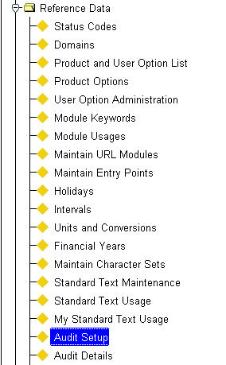Figure 1

Audit Setup

Menu Option

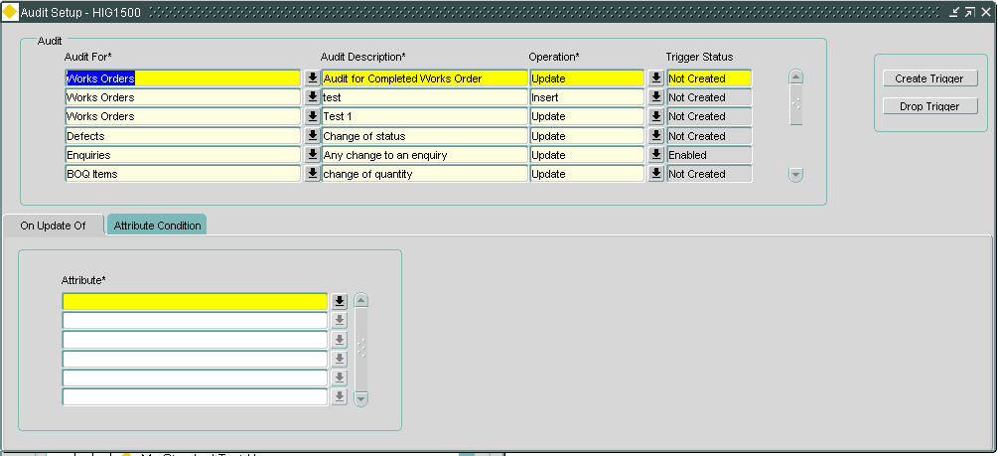

Figure 2

Audit Setup

General Information

This form is used to define the rule sets on the items and attributes that are to be audited.

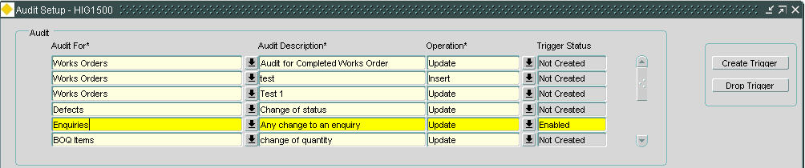Figure 3

Audit

Audit

Triggered events can be set up when the rule is defined with the conditions under which an audit should take place

When you enter this window, the cursor sits in the ‘Audit For’ field waiting for you to enter your new data. Press [**Execute Query**] to obtain existing information.

Audit For (Required) List

Enter the item on which audit triggers should be created.

Only foreign table assets will be available for selection.

Currently the default list consists of the following:

* Work orders
* Work order lines
* BOQ items
* Defects
* Enquiries
* Automated processes

Note: System Administrators may configure additional tables that are to have audits placed on the data therein. To carry out his task refer to the *Asset Manager Admin* guide.

Audit Description (Required)

Enter a description of the audit. It is important that a sensible description is entered as there may be multiple audits for each of the items listed above and the description is the only way to quickly identify the audit details.

Operation (Required) List

Enter the operation type. An operation type will depend on whether the audit has been defined to act on one of the following:

1. Creation of a new item – *Insert*.
2. The update of an existing item – *Update*. The ‘Update’ tab is only available with this operation set.
3. The deletion of an item – *Delete*.

Values available are Insert, Update or Delete.

The operation cannot be updated on a saved audit, if a change is required it should be deleted and re-entered.

Trigger Status (Display Only)

The status of the audit trigger will be displayed. This could be Enabled, Disabled or Not Created. Once the trigger has been created or edited it will need to be enabled, this is done by selecting the required audit and selecting the [Create Trigger] button.

When the audit criteria is edited, the system will automatically drop the trigger so consistency is maintained, a message will be displayed informing the user of this.

**[Create Trigger]**

Use this button to create a database trigger against the Oracle table named by the foreign table set against the asset metamodel in form ***Asset Metamodel – NM0410***. Once created the ‘Trigger Status’ field will be highlighted in green with the ‘Enabled’ text being displayed.

If an existing audit is modified for any reason the user will have to re-create the trigger with this button before the audit will function.

**[Drop Trigger]**

Use this button to drop the Oracle trigger created for generating the audit. The trigger status will change to ‘Not Created’ when this button is selected.

This will disable the trigger until it is required to be re-created using the [Create Trigger] button.

Editing the criteria will also drop the trigger, the user will be notified the trigger will need re-creating.

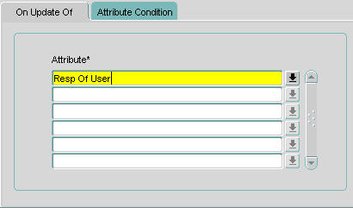Figure 4

On Update Of

On Update Of

Audits can be triggered on the update of any attribute within the selected items metamodel. The list of values will contain all attributes held against the selected asset type in the ‘Audit For’ field.

This tab will be enabled only if the ‘Operation’ is defined as ‘Update’.

Attribute (Optional) List

Enter the attribute for the selected item that, if updated, is to be used for the audit trigger.

If multiple attributes are entered here the audit will audit each attribute.

The list of values will contain all attributes held against the selected item type in the ‘Audit For’ field.

Note: this field can be left blank if the audit is to be generated for any modified attribute on the item selected.

Figure 5

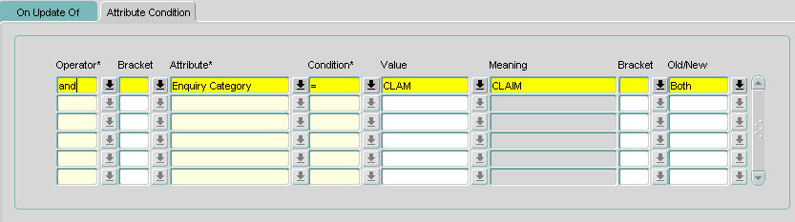Attribute Condition

Attribute Condition

Audits can be triggered if the attributes meet the conditions defined in this tab.

Operator (Required) List

Enter the operator for the condition. Valid values are AND and OR, default is AND.

Bracket (Optional) List

Enter the opening bracket of the condition if required.

Attribute (Required) List

Enter the attribute to be used for the condition.

The list of values will contain all attributes held against the selected item type in the ‘Audit For’ field.

Condition (Required) List

Enter the condition to be used for the attribute. These are a subset of standard Oracle conditions.

If a condition of ‘BETWEEN’ is required ‘>=’ ‘AND’ ‘<=’ should be used with the appropriate brackets for a sensible condition. An example of this is shown below:

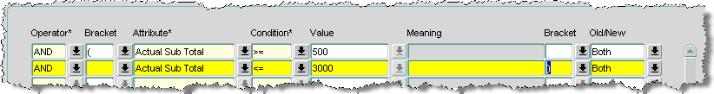

If a condition of ‘IN’ is required several ‘=’ and ‘OR’ should be used with the appropriate brackets for a sensible condition. An example of this is shown below:

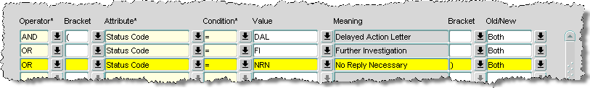

Value (Required) List

Enter the required ‘query’ value of the currently selected attribute. If the attribute values are held in a domain, the list of values may be called.

If the LIKE condition is used wildcards ‘%’ or ‘_’ may be used in the value field.

Meaning (Display Only)

If the attribute values have an associated list of values the description of the selected value will be displayed.

Bracket (Optional) List

Enter the closing bracket of the condition if required.

Old/New (Optional) List

This field is used to check the attribute for values that are either old or new or both.

This field is applicable only if the ‘Operation’ is defined as ‘Update’.

Example of setting an Audit rule set

This example is to set a rule to audit any changes made by a user to a flooding incident in Enquiry Manager.

The system will record:

* Date and time of change
* Name of the user who modified the record
* Details of the changes made

Set up Audit fields:

1. Audit For – ‘Enquiries’
2. Operation – ‘Update’

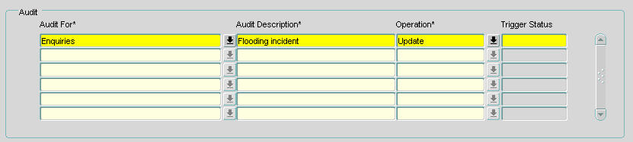

Figure 6

On ‘Attribute Condition’ tab

1. Operator – ‘AND’
2. Attribute - ‘Enquiry Type’
3. Condition – ‘=’
4. Value – ‘FLD’ (Flooding)
5. Old/New – ‘Both’

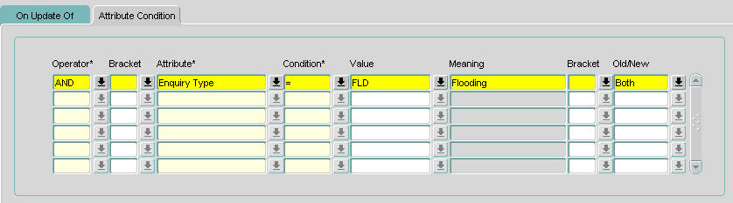

Figure 7

1. Save the record.
2. Select the [**Create Trigger**] button to start creating the Audit.

This will now create an audit log when an enquiry record with a type of FLD - Flooding is changed.

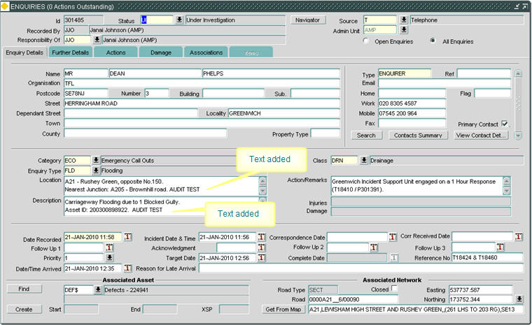

Figure 8

Enquiry Id 301485 was updated from with AUDIT TEST text in the ‘Location’ and ‘Description’ fields.

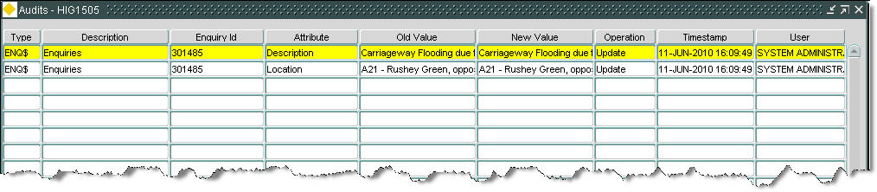

Figure 9

An audit is generated for Enquiry Id 301485 for attributes Location and Description.

Call Audit Details from Navigator

Audit details can be viewed through Navigator. If Audit is available for the selected tree node the Audit module should appear in the pop-up menu in the tree.

This example shows how to view audit details for Enquiry Id 301485 as created in the example of setting Audit rule set.

**To view Audit details through Navigator:**

1. In the Enquiries – DOC0150 form query back Enquiry Id 301485.
2. Press the [**Navigator**] button.

This will call the Navigator module showing details of the enquiry.

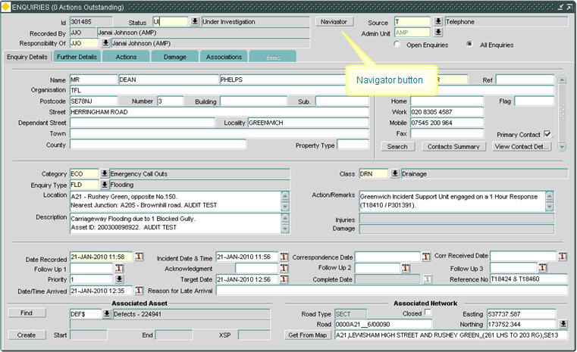

Figure 10

1. In Navigator highlight the enquiry line and right click with the mouse.

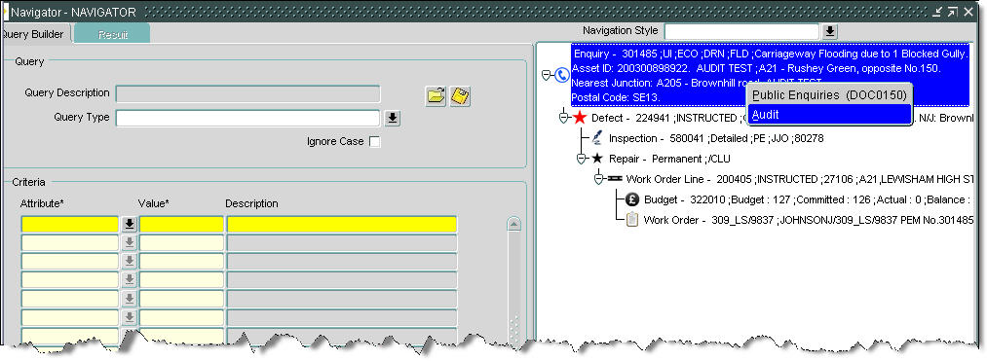

Figure 11

1. Select the ‘Audit’ option.

This will call the form Audit – HIG1505.



Figure 12

1. Audit details of the selected enquiry will be shown.

Audit Details – HIG1505

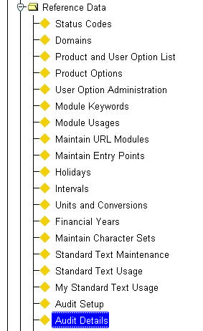Figure 13

Audit Details

Menu Option

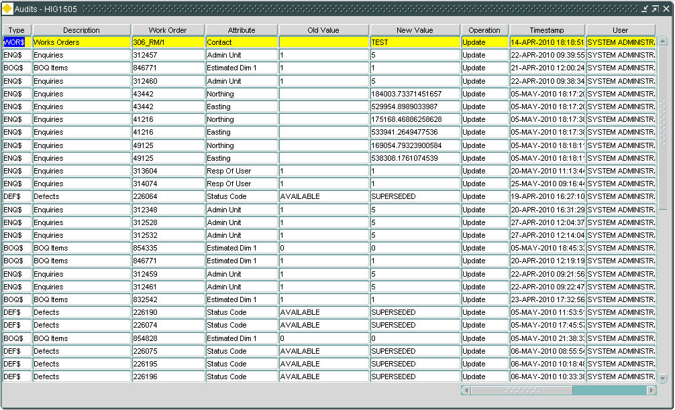Figure 14

Audit Details

General Information

This module is used to view audited information.

All fields in this screen are queryable. Users can, for example, query back all audits for specific records.

Sorting Results

Results within the Audit Details module may be sorted by any of the displayed fields by pressing the field name (column heading) which are also ‘Sort’ buttons. The first time a heading is pressed the records are sorted in ascending order. If pressed again the records within the column will be sorted in descending order. A ‘carat’ (^) symbol or lower case ‘v’ is displayed adjacent to the column name to indicate that the data has been sorted in ascending or descending order respectively as shown below.

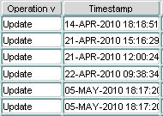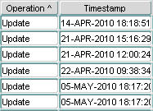

Figure 15

Sort

Audit Details

Type (Display Only)

The item on which audits are configured will be displayed.

Description (Display Only)

The description of the item selected will be displayed.

Id (Display Only)

The value of the primary column of the item will be displayed.

The primary column is the screen text of the primary key column as defined in the Asset Metamodel – NM0410.

The heading will change depending on the ‘Type’ of asset used for the audit.

I.e. if the type is ENQ$ the heading will show ‘Enquiry Id’. If the type is DEF$ the heading will show ‘Defect Id’.

Attribute (Display Only)

The audited attribute name will be displayed.

Old Value (Display Only)

The old value of the audited attribute will be displayed.

New Value (Display Only)

The new value of the audited attribute will be displayed.

Operation (Display Only)

The operation used for the audit rule will be displayed.

This will be either Insert, Update or Delete.

Timestamp (Display Only)

The date and time the audit was created will be displayed.

User (Display Only)

The user who made the change that was audited will be displayed.

Use the scroll bar to view further fields.

Terminal (Display Only)

The terminal or server that was used to make the change that was audited will be displayed.

OS User (Display Only)

The operating system user Id will be displayed.